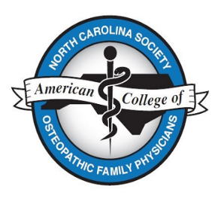

NCS-ACOFP Annual CME Conference
August 13 – 15, 2021 at the Pinehurst Resort
Registration Form
Name
Phone Email
Registration Fees for Conference - Friday - Sunday
Attendee Type | Early Bird Rates | Rates after July 5
NCS-ACOFP or NCOMA Member | $450 | $500
Out of state ACOFP physician member | $450 | $500
Non-member physician | $500 | $550
Active duty military physician | $250 | $300
Retired physician | $250 | $300
Residents | $75 | $100
Students | $30 | $40
Guest (includes meals only) | $150 | $150

Circle fee amount(s) above that you are paying and enter total here
I need an invoice reflecting amount owed and amount paid: Yes No

I plan to attend the evening reception on 8/13: Yes No

I plan to attend the conference virtually, that is, I will not be on-site: Yes No

I wish to reserve a spot for the Cradle Short Course on Sat., 8/14 at 6:15 pm. I understand the cost is $50 that is due at the time of play: Yes No

Payment and Registration Options:
1) Complete this application and submit with a check made payable to NCS-ACOFP. Mail to:
Nancy Guy, NCS-ACOFP Director
PO Box 4280
Buies Creek, NC 27506

2) Register and pay-line on the NCS-ACOFP website (https://nc-acofp.org/)/Conferences

Conference Contact: Nancy Guy, 910-893-7960 or guy@campbell.edu

